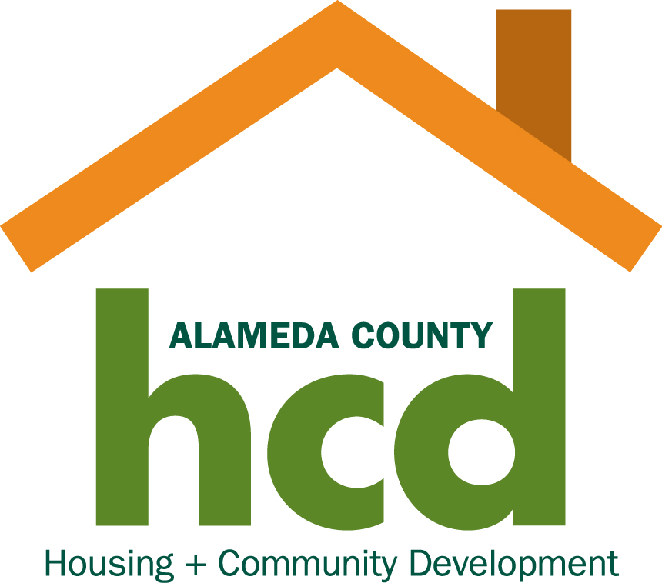

COUNTY OF ALAMEDA
HOUSING AND COMMUNITY DEVELOPMENT DEPARTMENT
MULTIFAMILY HOUSING REVENUE BOND PROGRAM
PROJECT APPLICATION

APPLICANT INFORMATION Date of Application _______

Applicant Name ___________________________________________________________
Applicant Address ___________________________________________________________
Contact Name ___________________________________________________________
Email Address ___________________________________________________________

Phone and Fax ___________________________________________________________
Phone Fax
Applicant Fed. Tax I.D. No __________________________

Applicant Type Non-profit □ For-profit □ Partnership □ Other □
General Project information
Project Name ____________________________________________________________
Project Address ____________________________________________________________

Assessor’s Parcel Number(s) ________________________
Number of Acres ________________________
Number of Units ________________________
New
______________ _______________
Existing After Rehabilitation
Type of Project and Financing
(check one) New Construction □ Acquisition Rehabilitation □ Acquisition Only □

BOND FINANCING INFORMATION
Bond proceeds will be for: Construction Loan □
Permanent Loan □
If permanent loan only, has construction financing been obtained? Yes □ No □
If yes, name of construction lender __________________________________
If no, describe status and timing toe construction financing.
_____________________________________________________________________________________________
Bond Amount $_______________________________
Initial Interest Rate ________________________________
Term ______________________ Years
Estimated Annual Debt Service ________________________________
Rating Agency and Rating ________________________________
Type of Credit Enhancement ________________________________
Name of Credit Enhancement Provider ________________________________
Credit Enhancement Provider Contact _____________________________________________
Name and phone number
Status of Credit Enhancement Commitment (and when expected) _____________________________________
___________________________________________________________________________________________
Summary of Proposed Bond Structure (i.e., variable or fixed rate; amount of any proposed unrated bonds; amount of any taxable bonds and a detailed breakdown of their use, etc.) Attach page if necessary.
___________________________________________________________________________________________
___________________________________________________________________________________________
Approximate Date of Proposed Bond Closing ____________________________________________________
Name of Preferred Investment Banking Firm ____________________________________________________
Contact _____________________________________________________________________________________
Name Phone Fax

Certification/Authorization
____________________________________________, an authorized representative of the developer, certifies that the
information contained in this application is true and correct. Authorization is provided to the County of Alameda
Housing and Community Development Program (HCD) to verify information provided in this application, including but
not limited to the developer’s credit rating, status and payment history of real estate loans and performance on
contracts with third parties. HCD is further authorized to use photocopies of this authorization to obtain third
party contractual and credit references and status of the developer’s obligations. The confidentiality of the information
you have furnished will be preserved except where disclosure of this information is required by applicable law.
Signature _________________________________________________
Printed Name _________________________________________________
Title _________________________________________________
Date _________________________________________________
PLEASE SUBMIT TWO COPIES OF THIS APPLICATION WITH ALL ATTACHMENTS TO:
Housing Director
Alameda County
Housing and Community Development
224 West Winton Avenue, Room 109
Hayward, CA 94544
Fax: 510-670-6378

Please call 510-670-5211 if you have any questions.

